Group no: 7

1. Faiza Tasnim-(19-41552-3)
2. Syeda Faiza Karima-(20-43073-1)
3. Sharia Tasnim Adrita-(20-41895-1)
4. Sadia Afrin Sara – (20-41834-1)

CLASS Diagram of Medicare:

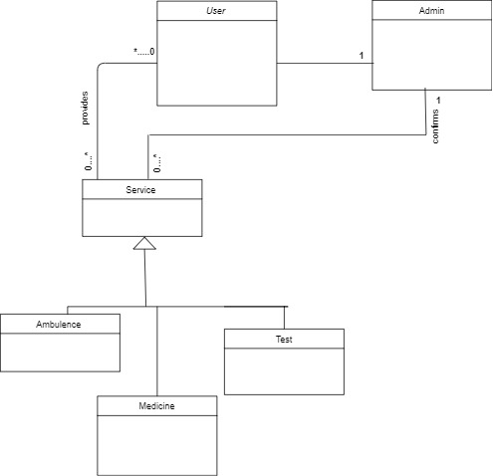

Class Component:

